ZH Full Color Asynchronous Mobile Phone Software Operation Manual

- Open Mobile Phone Software.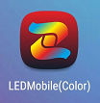
- Click the “CONNCT WI-FI PLEASE”, enter into the interface of linking with WIFI, and find the corresponding WIFI, then connect.
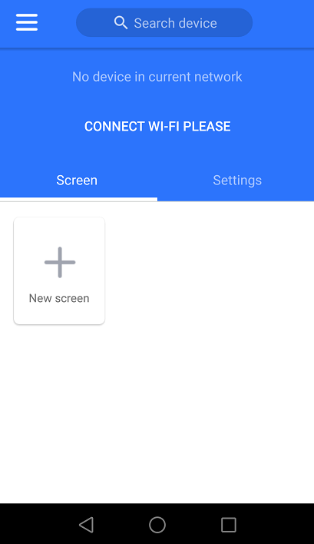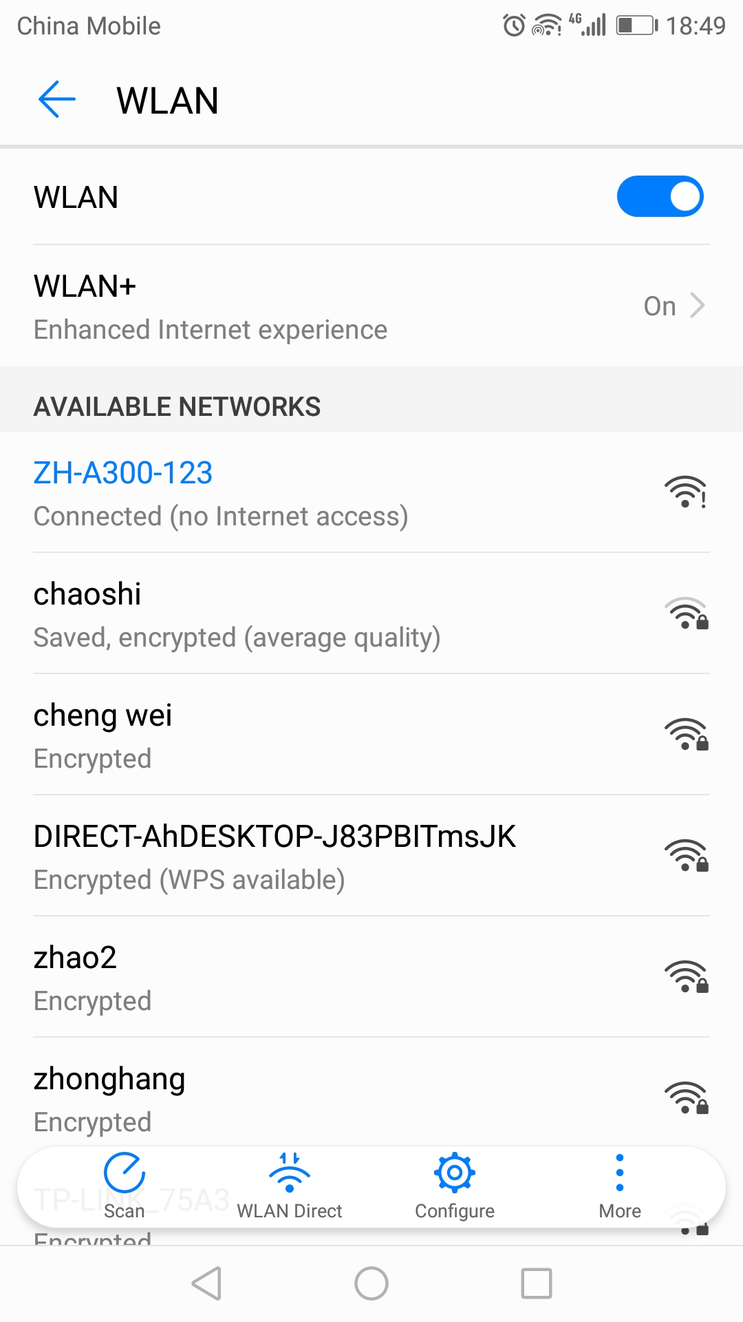

- After connect with WIFI, the software will show the information of the asynchronous card, click “Add Screen” to modify the corresponding “Width” and “Height”, then click “OK”.
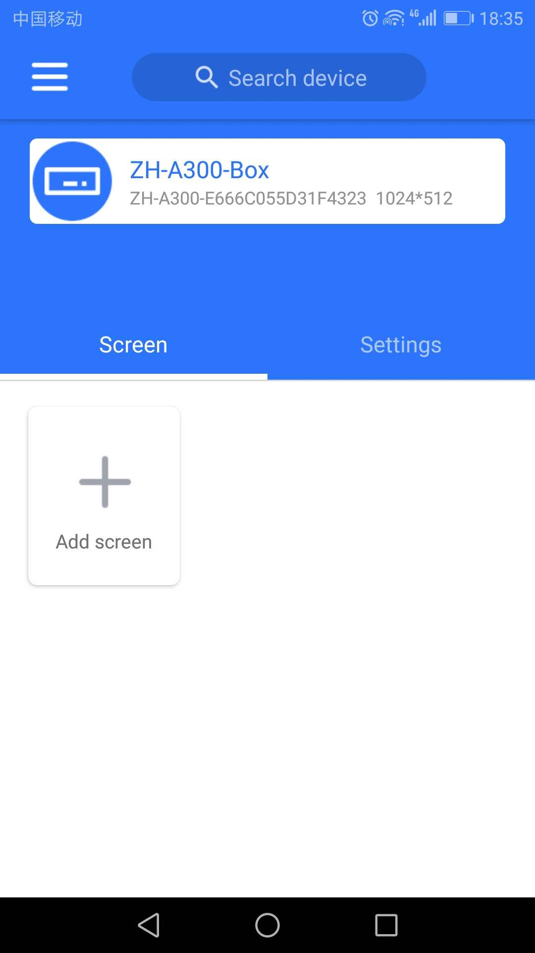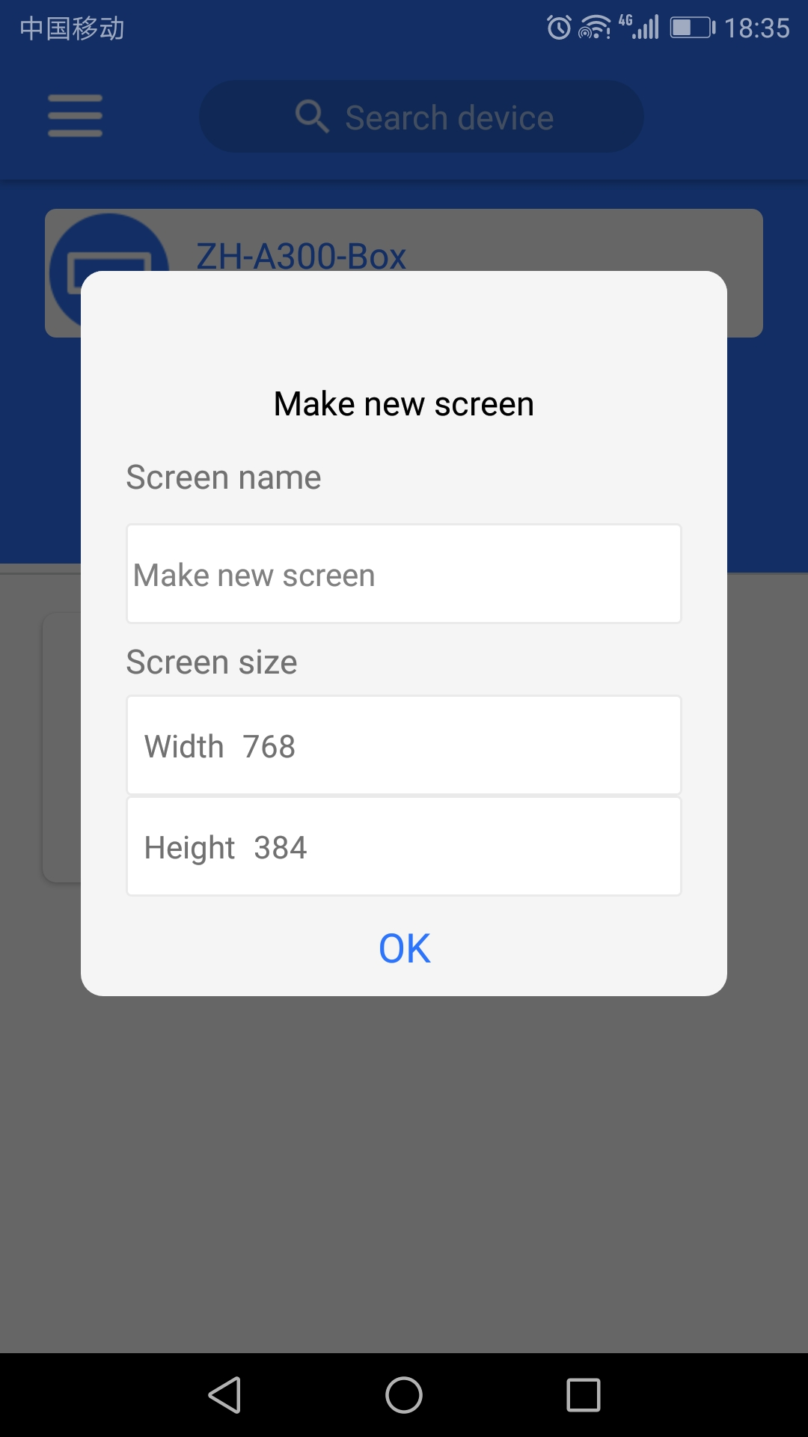

- After click “OK”, a window for adding material will pop up. Choose the corresponding material to add, then click “OK”.
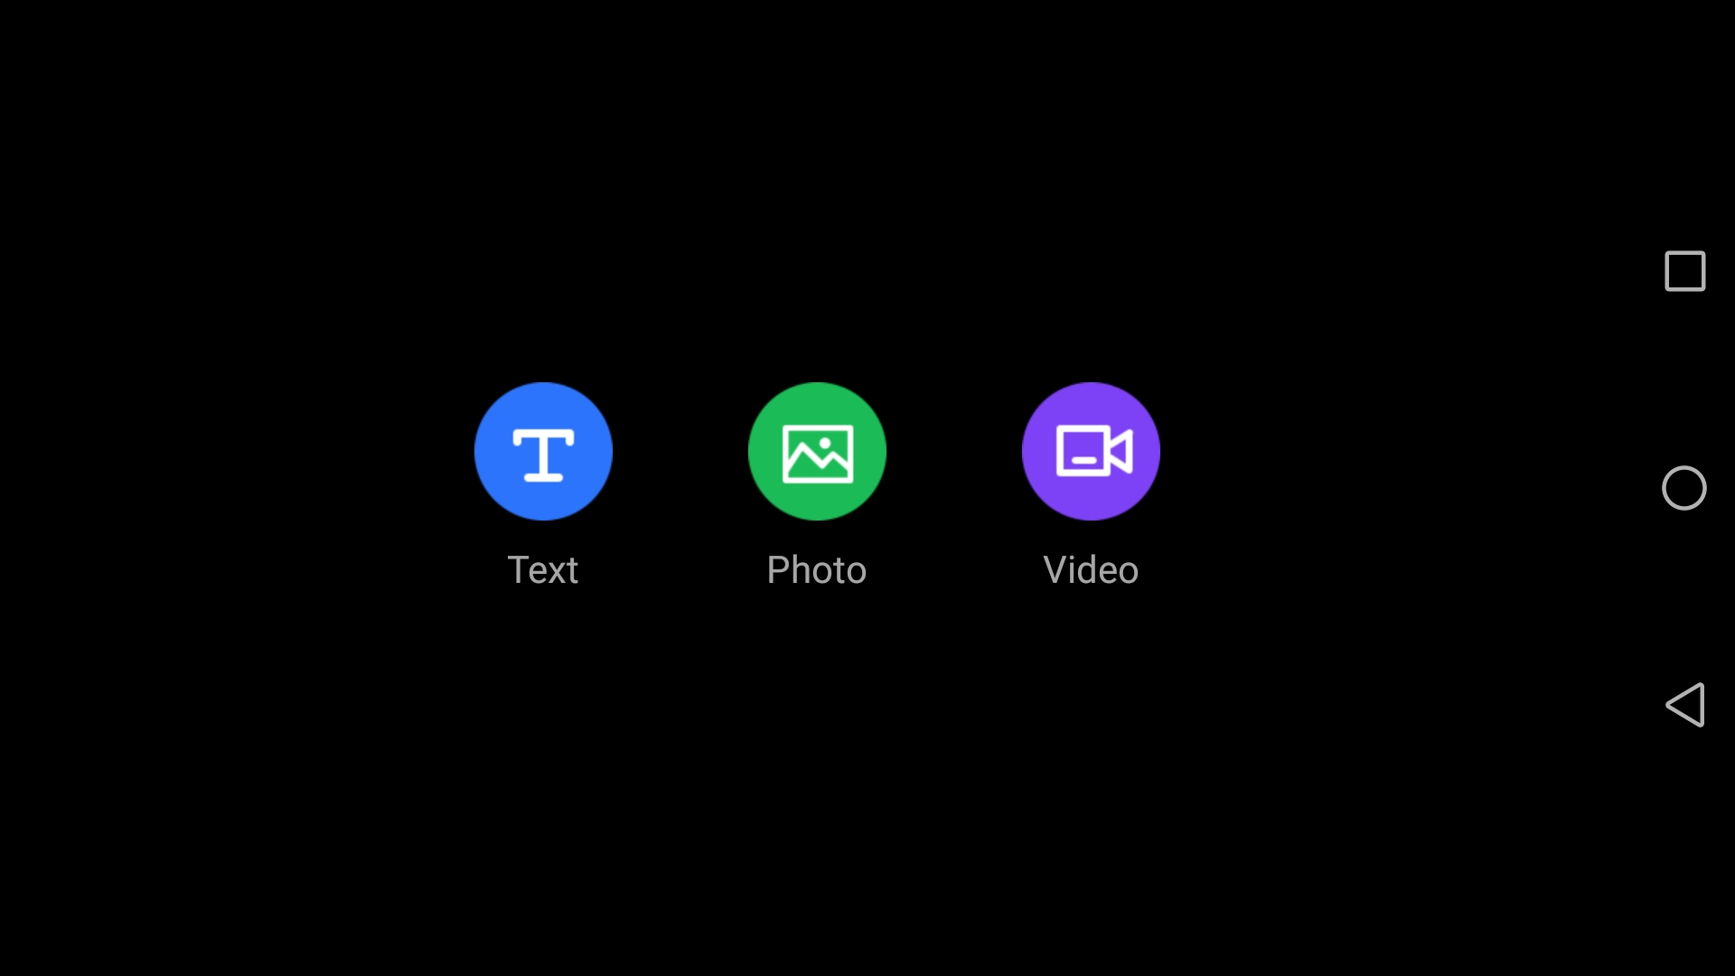

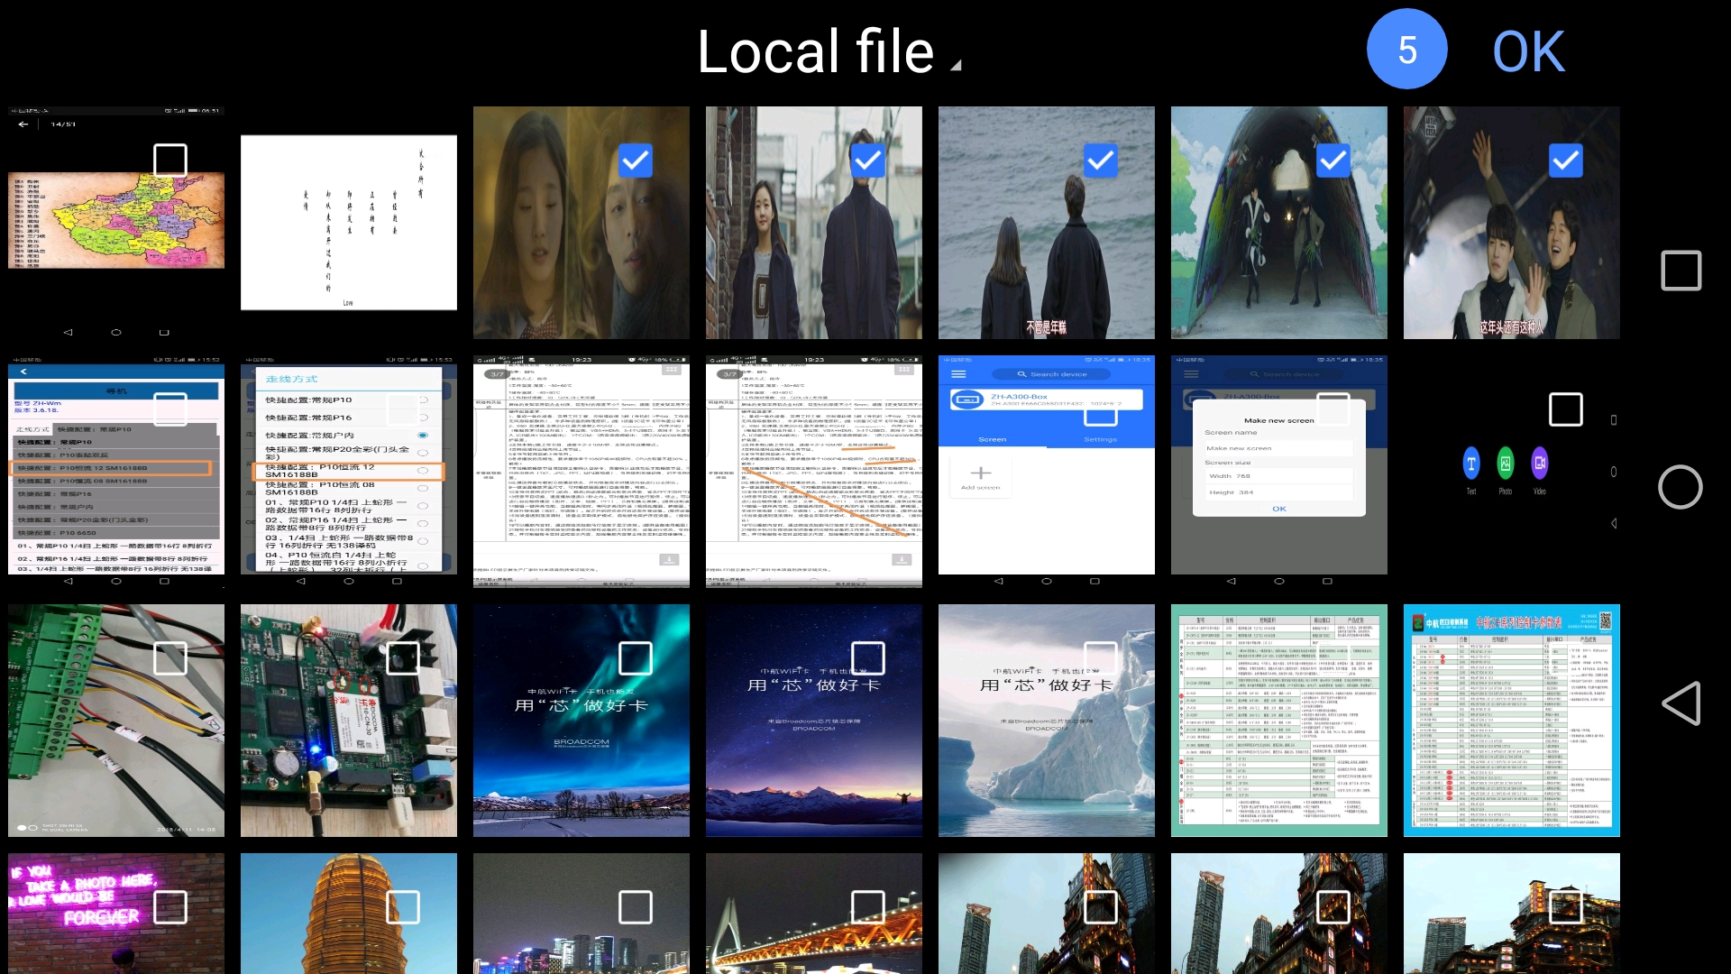

- Dragging the file window, to enlarge the size to be the maximum.
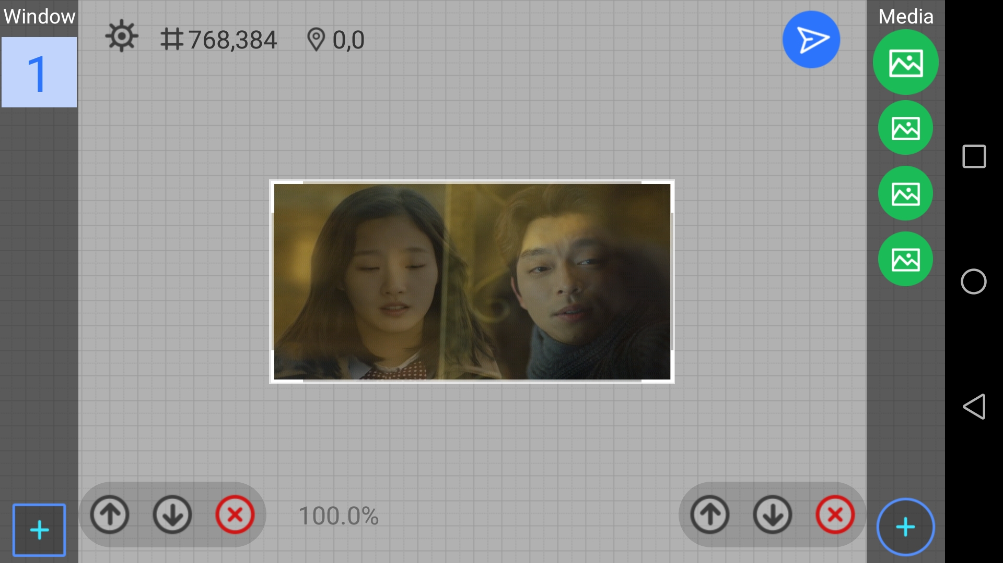

- Click the “Send” button in the upper right corner,  then click “Send”, the content will upload.

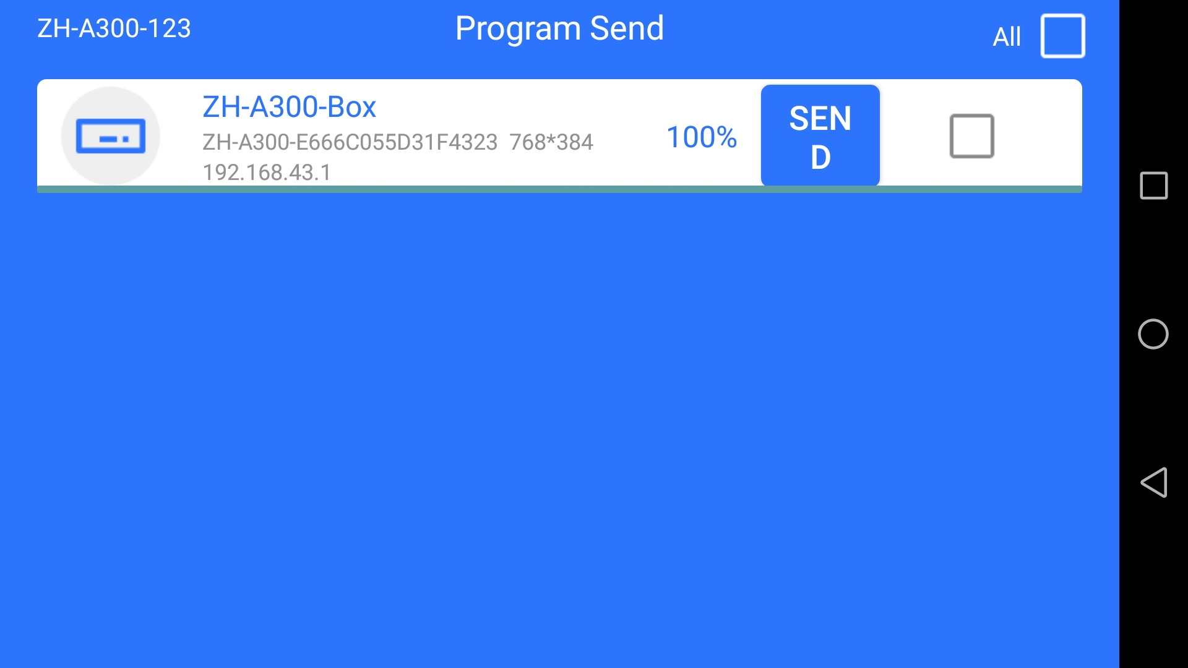

- After the above six steps, can show the edited content. In order to enrich the display of the LED Screen, the software also own multiple file window overlay display, material effects editing and other functions, the details are as follows:

First, introduce the function of each button in the software:

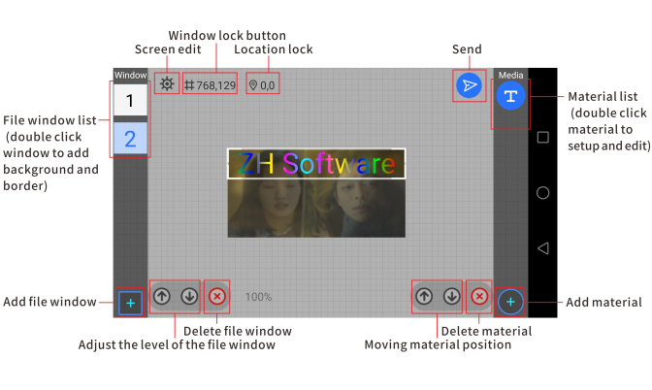

Second, the software also offer a variety of templates for users to select. If you do not want to edit manually, you can click the button in the blank area of the software preview interface, then it can show the following interface.

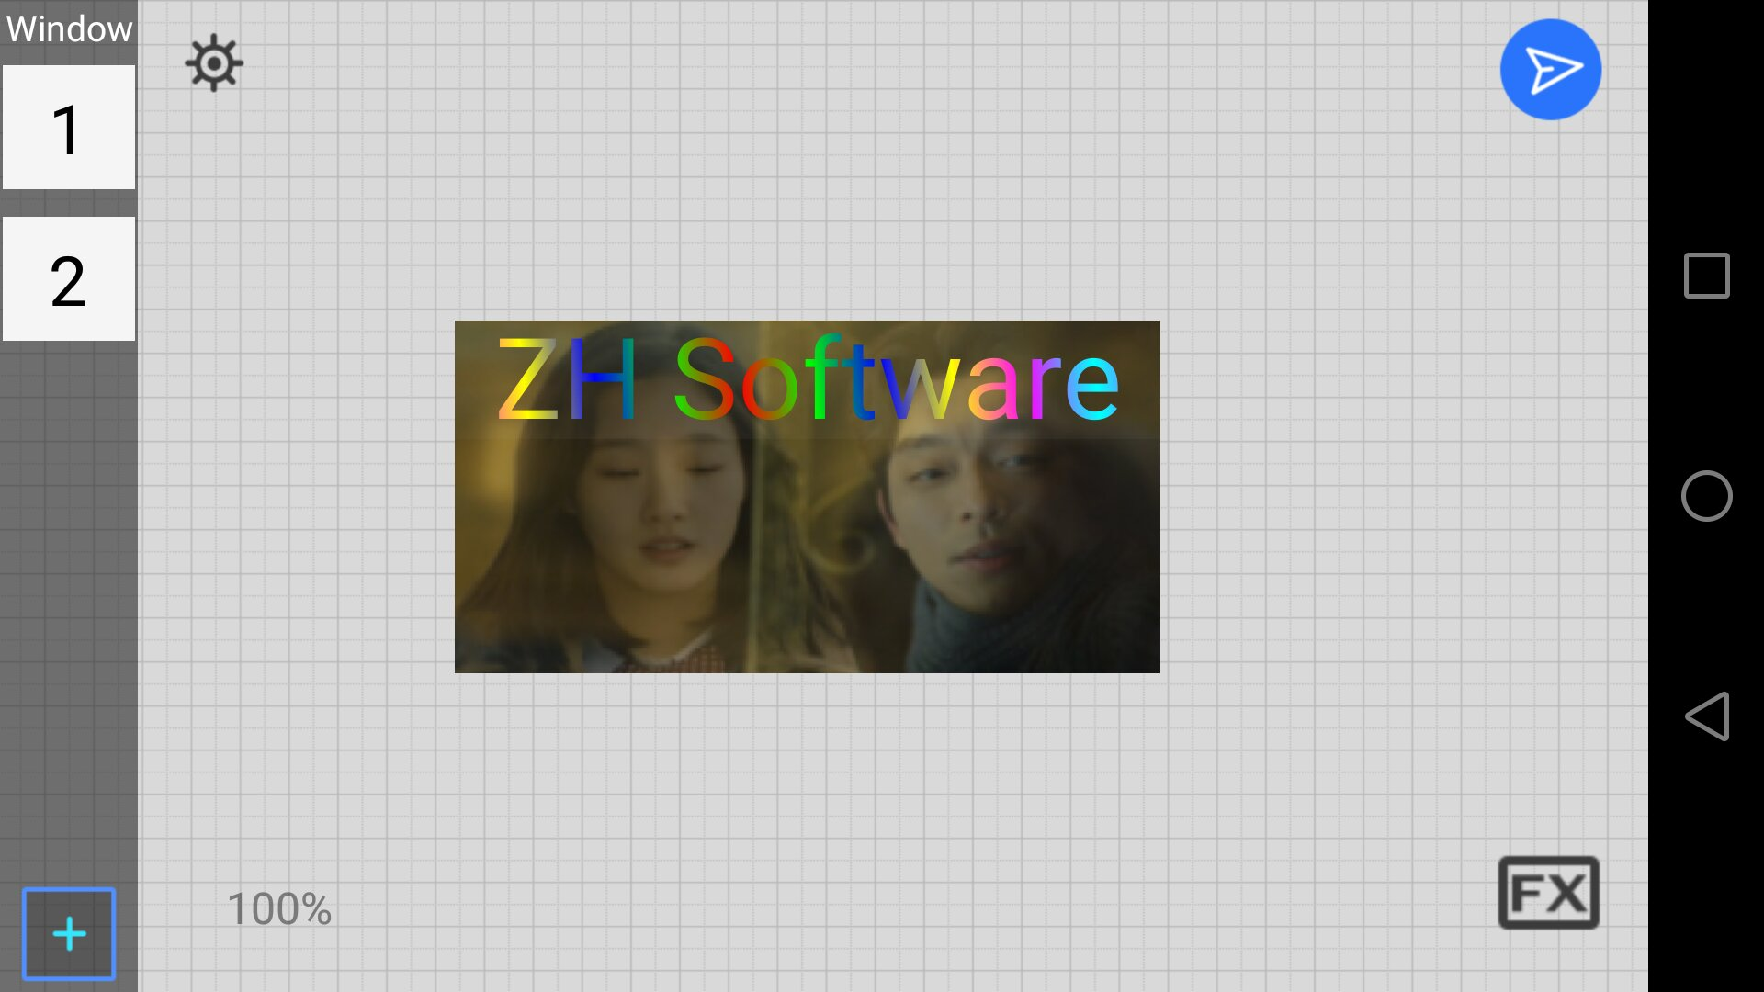

Third, click the FX icon in the lower right corner, can show various edited templates, after select, then edit the material, at last click “ Send ” is OK.


